**User Manual**

**Table of Contents**

**pg no.**

**a) Introduction .......................................................................................... 2**

**b) Motivation ........................................................................................... 2**

**c) How to use Application.............................................................................. 2**

**d) Error Recognition and Handling ............................................................. 2**

**e) Interaction with the Application............................................................... 3**

**f) Bugs and Deficiencies ................................................................................. 15**

**a) Introduction:**

M Snake Sensor Based Game is a project done to fulfill the requirements of the course Big Data Analytics and Applications course for summer 2014. With this cool application User can play traditional Snake game with a new interactive way by using Sensor tag.

**b) Motivation:**

Gaming environment plays a crucial role during daily activities in every individual’s life. Especially right from children to students and professionals and even old persons play games during their leisure activities in order to reduce stress and for relaxation. Especially gaming environment on phones became more popular through the smartphones that are available in current market. Some of the traditional games such as Snake game that was previously played right from non-touch environment to touch based environment. Previously this snake game used to operate through buttons available on the phone and then gradually through the touch event available in today’s smartphone. Since the course Big Data analytics and applications deals with data analysis with different types of sensors, we opted a motion base game M Snake and developed the application in such a way that the game can be played with an innovative and effective way using sensors.

**c) How to use the Application?**

Application that we developed is user friendly and can easily understandable by the user. We developed our application using the open source M Snake Game application that enables user to play the tradition Snake game in new interactive way using Sensor Tag. This application supports the Android mobile having Bluetooth version above 4.3 and operating system 4.3. This application consists of four main options such as New Game, Analysis, Statistics using Pie charts and Statistics using Line Charts. Through the gaming option user can play the traditional snake game by connecting the sensor tag where the user will operate the orientation of snake with sliding the sensor tag to different directions. After user plays game he/she can check her statistics using the analysis option where the estimated amount of calories burnt for the game play will be displayed with the number of different gestures performed. Through the Statistics using Pie charts options users can view their statistics such as number of gestures performed for a game can be viewed. Through the Statistics using Line charts option, users can view their statistics using the Line charts where the time of the day is plotted on the X-axis and number of gestures made at a particular time are plotted on Y-axis.

**d) Error Recognition and Handling:**

While using this application user may experience errors while performing gestures through the M Snake application. When the user tries to perform gestures immediately after opening the application gestures might not be detected by the application since the application has to be trained before the user performs any gestures to operate the application. User may also experience certain issues with incorrect gesture recognition due to the incorrect handling of orientation of Sensor Tag. So user has to make sure to handle the sensor tag in the exact orientation in order to make the application respond properly. User may also experience errors with the statistics whenever the HBASE is down since gestures that would be performed by the user will be stored and retrieved from HBASE in order to plot on graphs and charts.

**e) Interaction with Application:**

* As mentioned before the following screenshot represents the main page of our application.

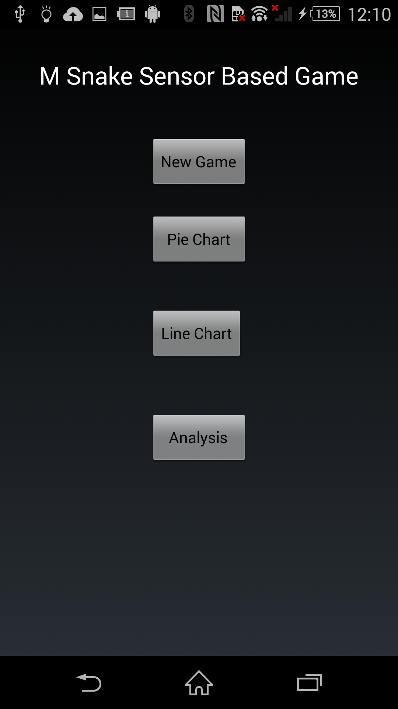

* User has to turn on the Sensor tag before starting the application by clicking on the side button provided to the sensor tag.

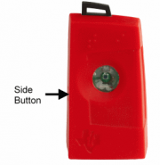

* User has to wait for a minute or two before playing the game so that the application will be trained with the given sequence files.
* User has to handle the senor tag in exact vertical orientation as shown in the figure below.

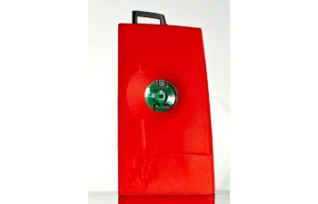

* After two minutes user has to click on the new game option provided in the application in order to start his/her game.
* User has to handle the sensor tag and operate with the given directions. User has to slide the sensor tag to his right in order to perform right gesture and move the snake towards the right side.



* When the user performs the right gesture then the snake will move towards its right as show below.

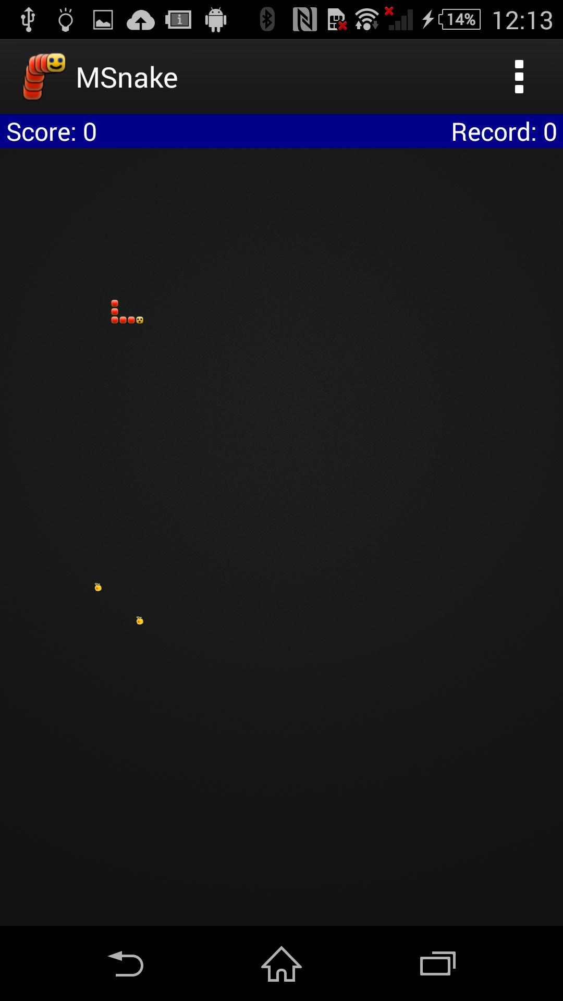

* User has to slide the sensor tag to his/her left in order to perform left gesture and move the snake towards the left side.



* When the user performs the left gesture then the snake will move towards its left as show below.

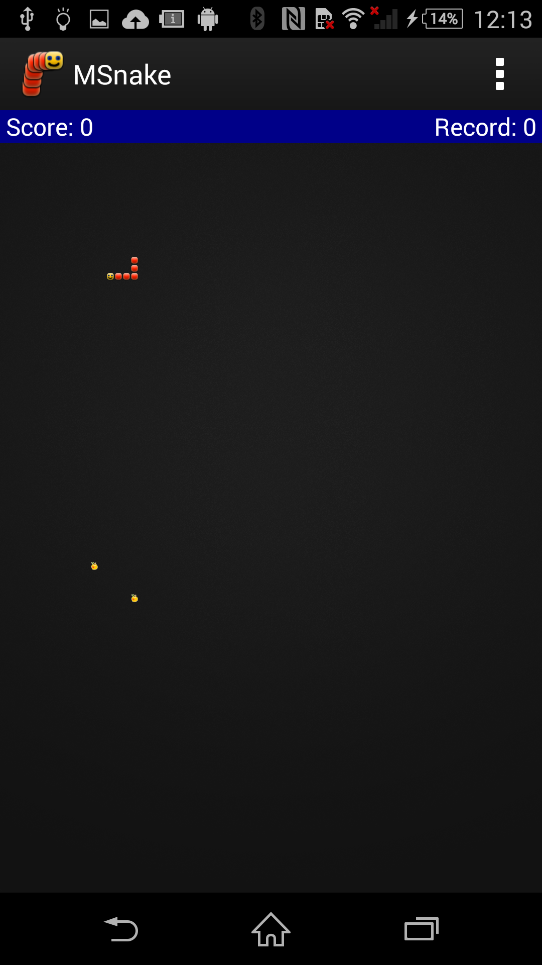

* User has to slide the sensor tag to his/her up in order to perform up gesture and move the snake upwards.



* When the user performs the up gesture then the snake will move upwards as show below

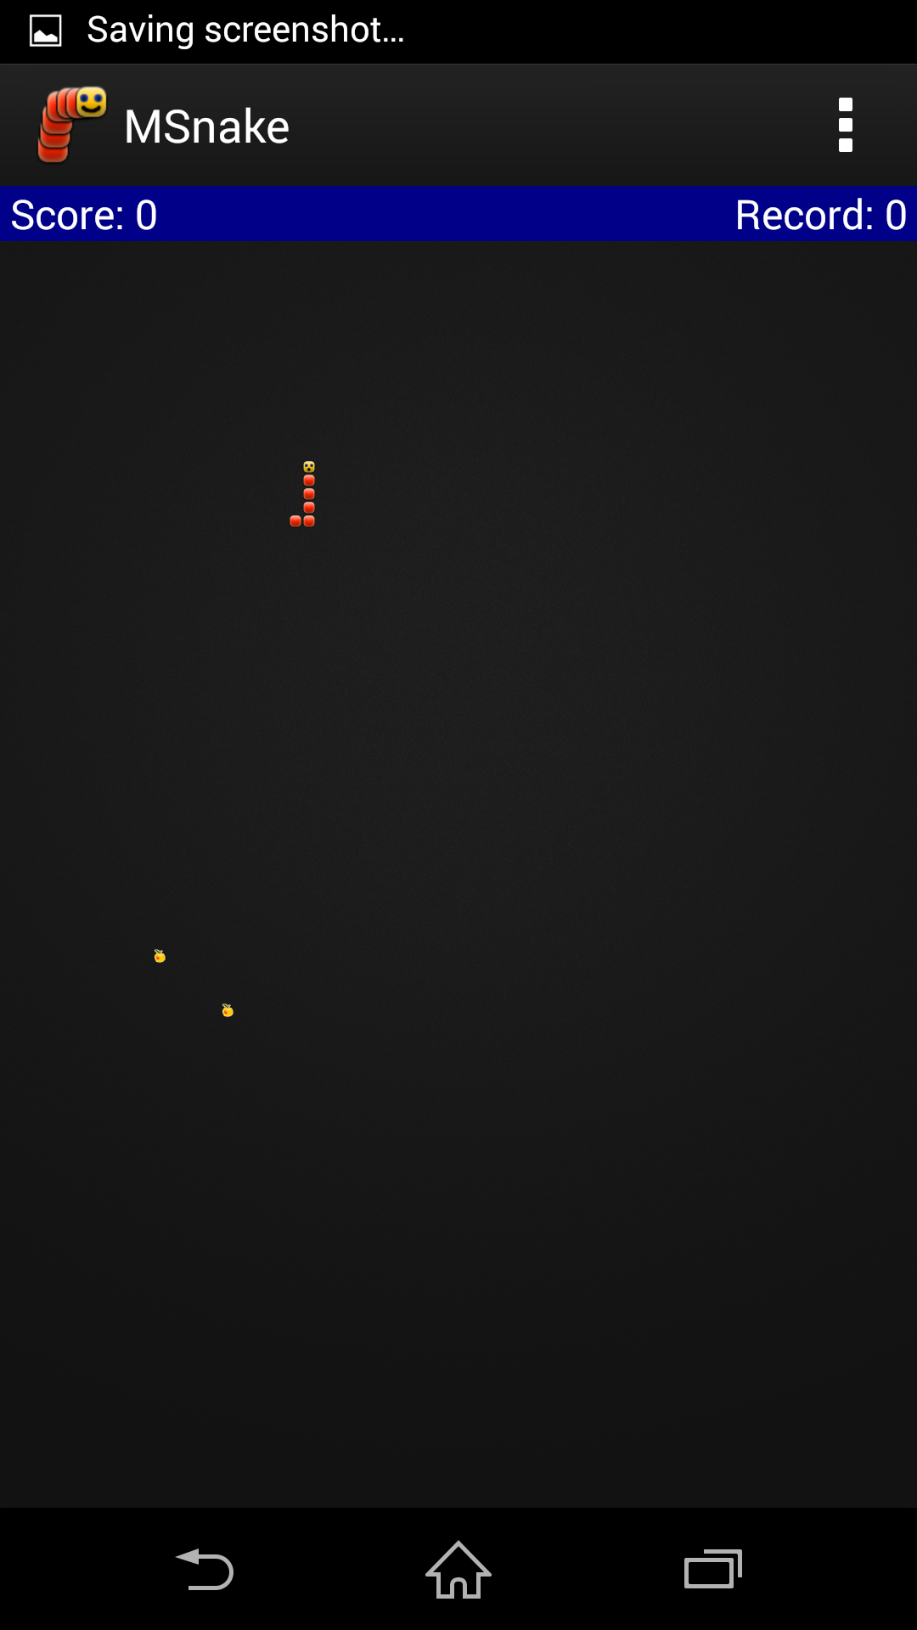

* User has to punch with sensor tag in order to perform down gesture and move the snake downwards.



* When the user performs the punch gesture then the snake will move towards its down as show below.

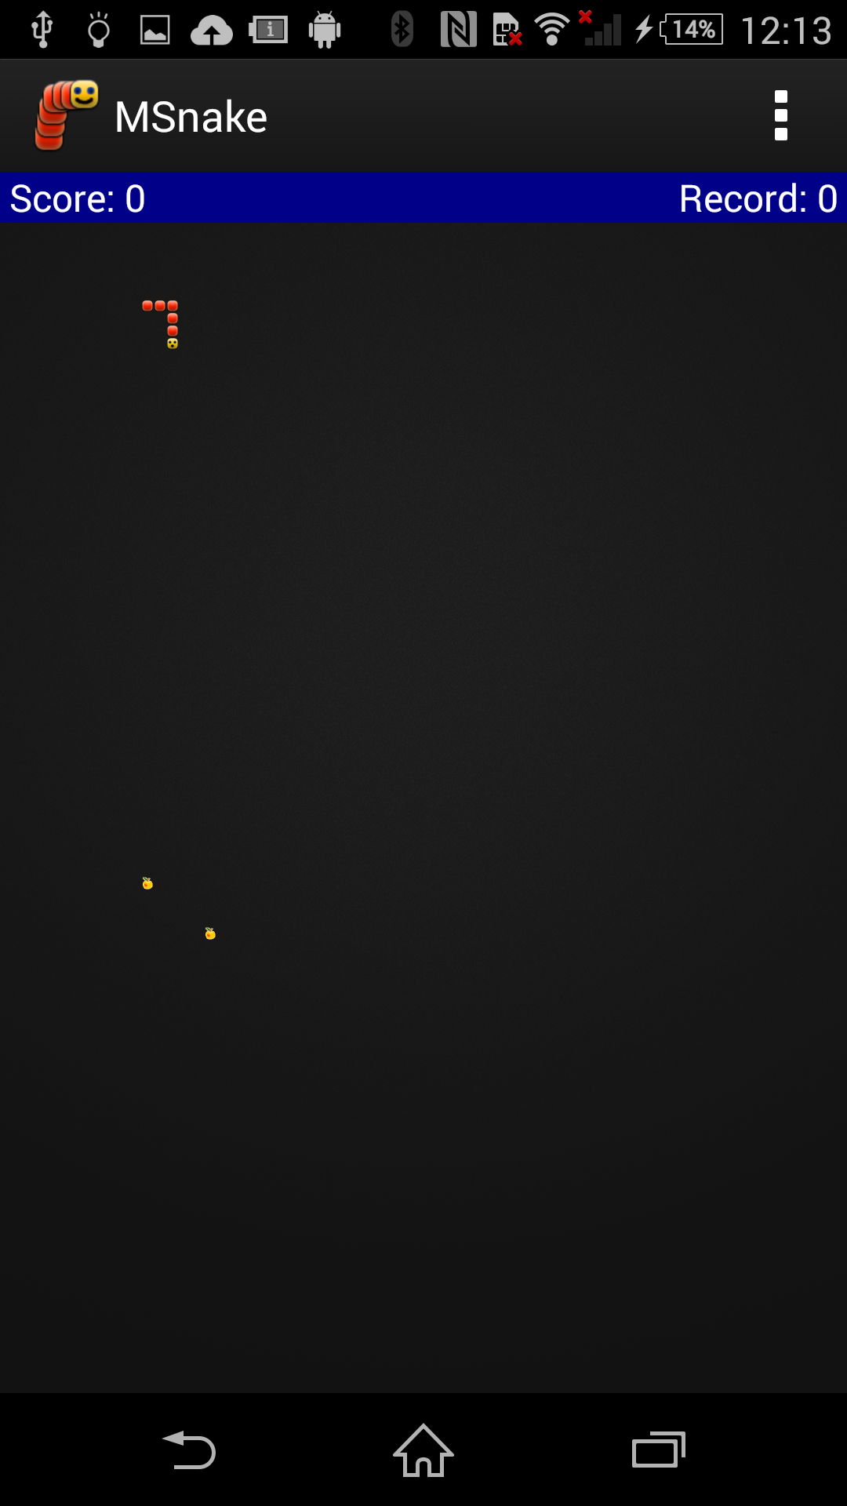

* When the game is finished User can view his stats through various options provided in the application.
* User can view his statistics using Analysis button given in home page. When user clicks on Analysis button, estimation of calories burnt and number of individual gestures performed are displayed.

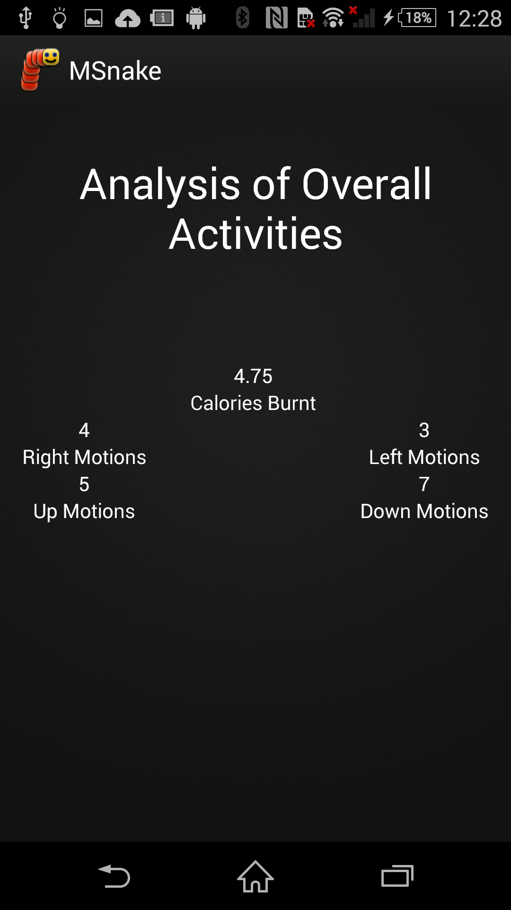

* User can also view statistics of his performance through pie charts view. When user clicks on pie charts button provided in the main page of the application, Pie chart with gestures weights will be displayed. When a user clicks on a sector, it displays the gesture that belongs to sector.

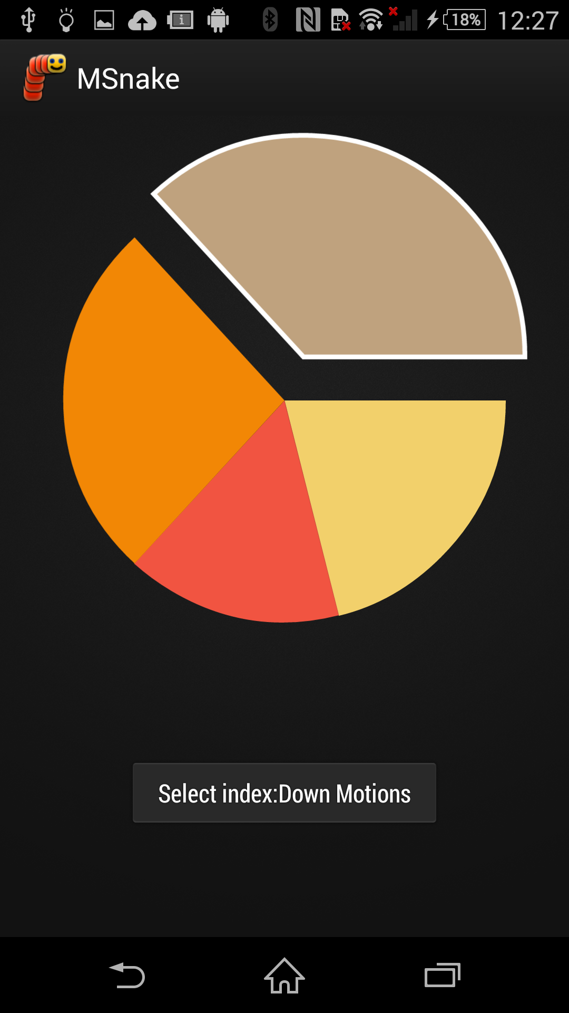

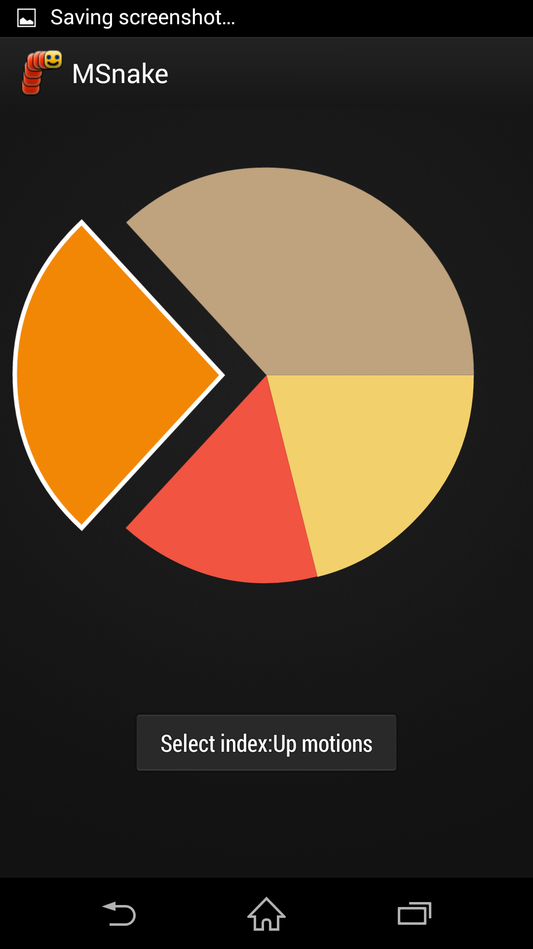

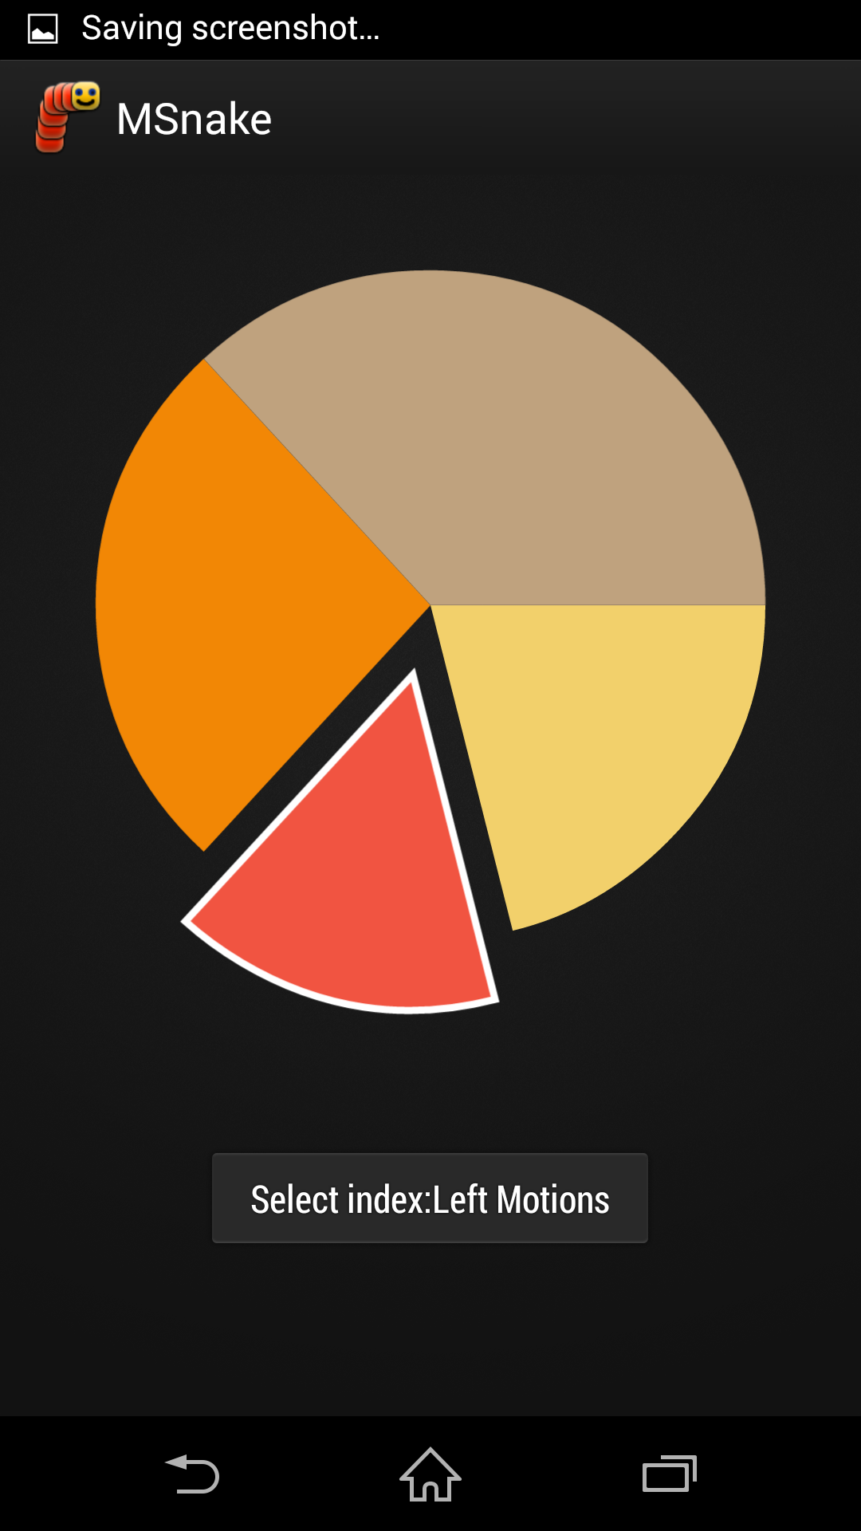

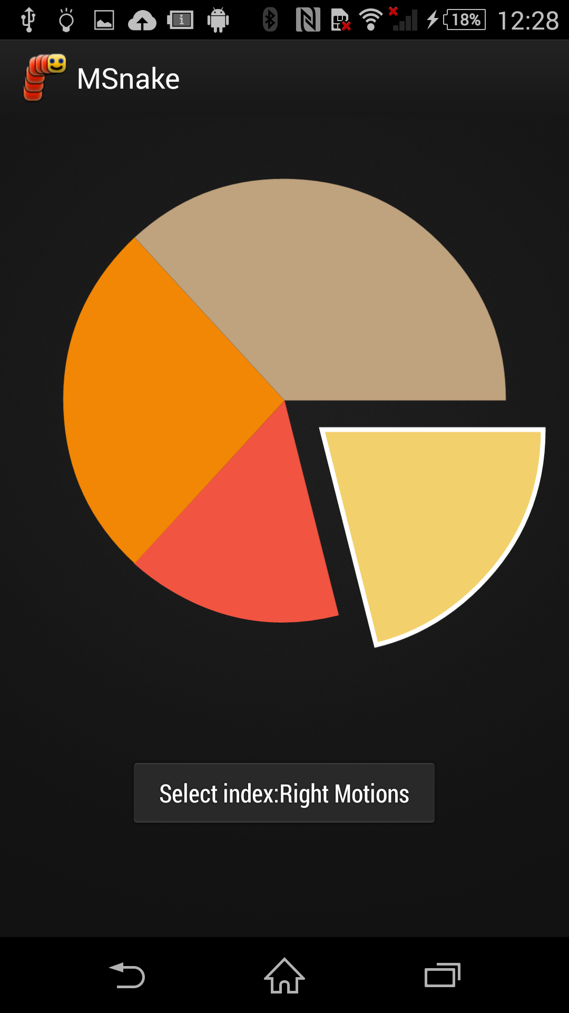

* User can also view overview of all gestures performed on that particular day. When user clicks on line chart button in the main page, line charts will be displayed with user performance.

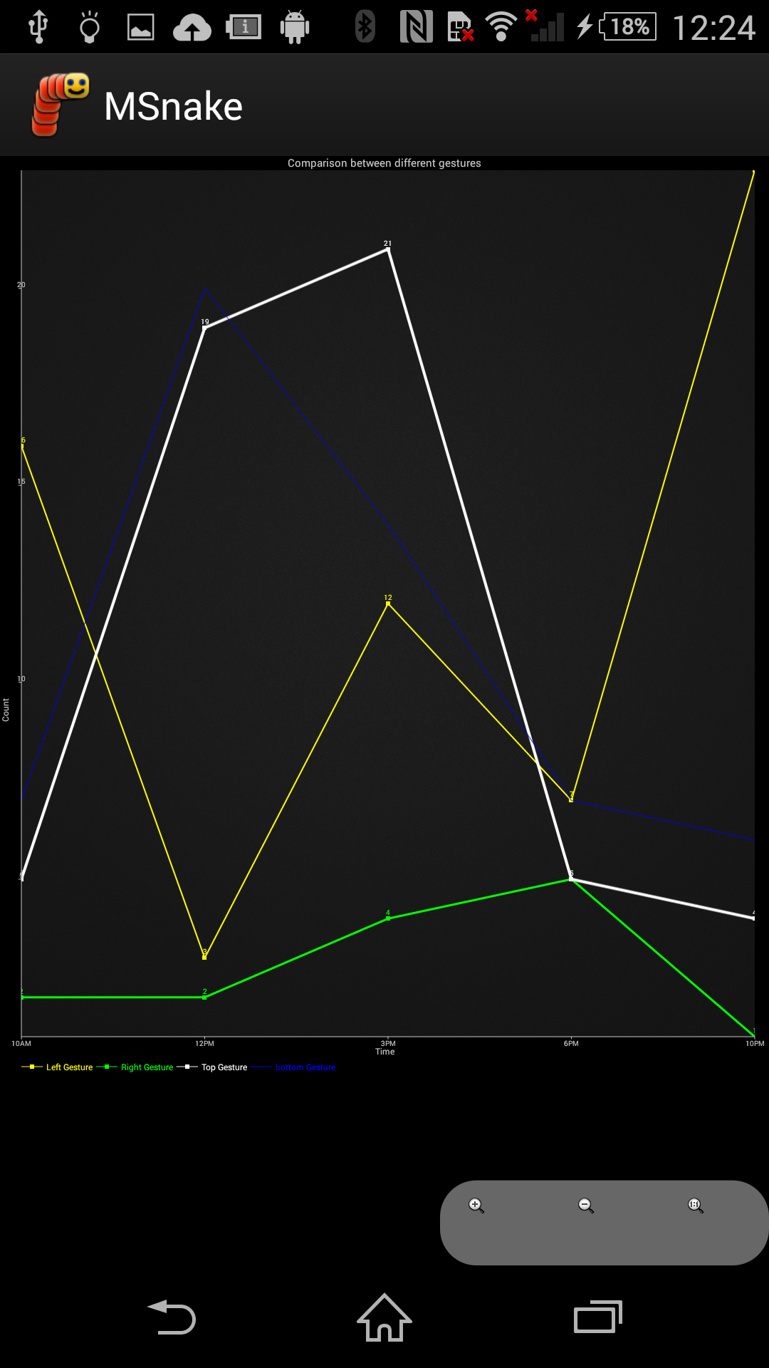

* Same process can be done by user for M Snake Samsung application in order to access the application.

**Bugs and Deficiencies;**

The only bugs and deficiencies that can be found in this application is with improper handling of sensor tag device may results in inaccurate gesture detection.